Lab Assignment 3

Form Wizard :
English Version, Form of Suppliers that lists the Company Name, Contact Name and City of each Supplier.
Form Wizard Steps:
1. 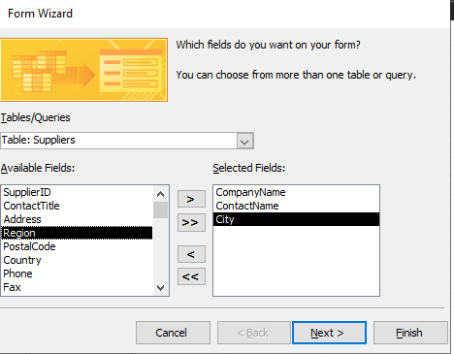

2. 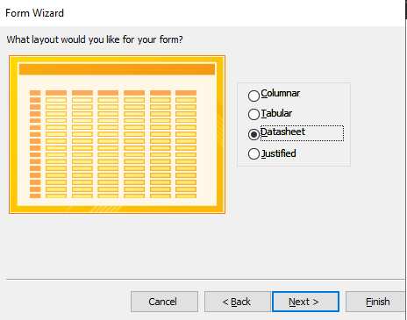

3. 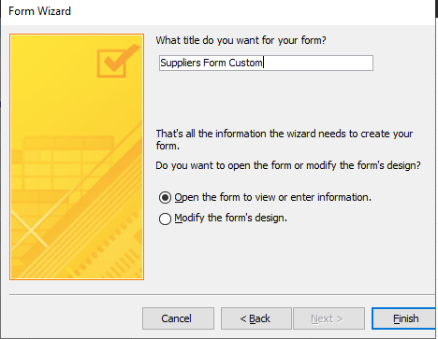

Results:
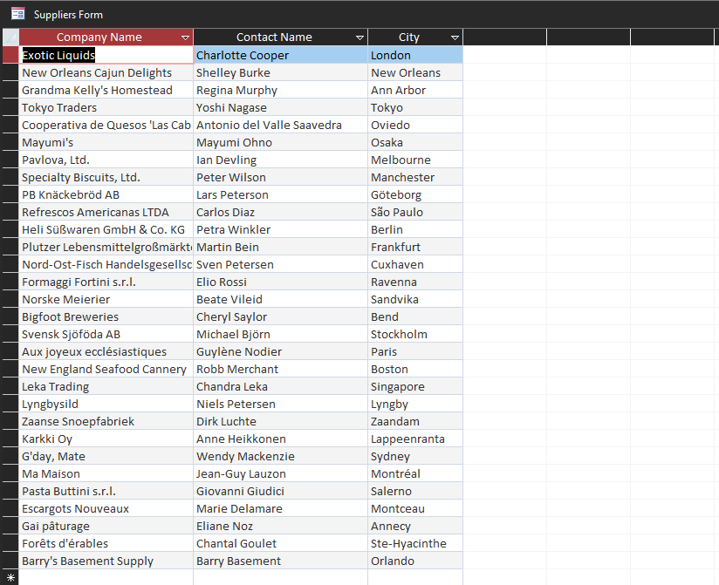

Report Wizard:
English Version, Report of Order Details that show the Order ID, Product name of items in each order and the Quantity ordered of each product.

Report Wizard Steps:
- 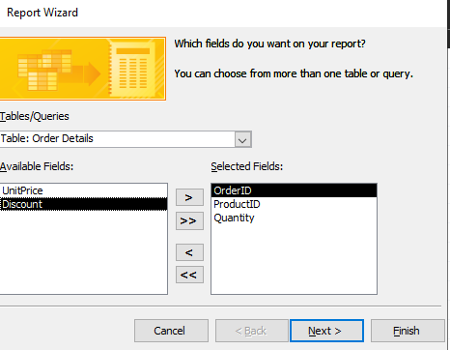
- 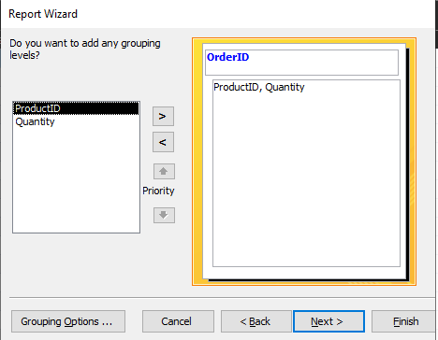
- 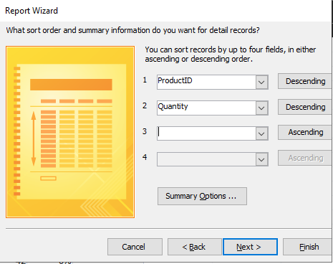
- 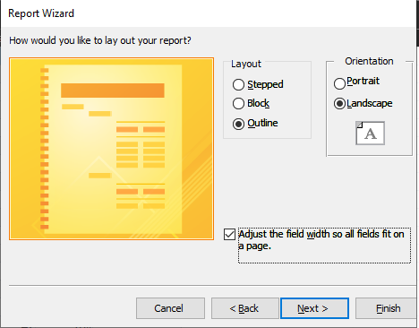
- 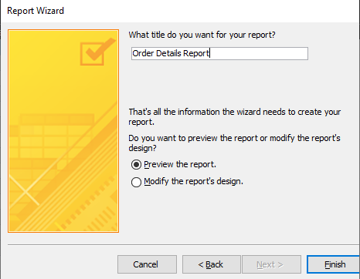
Results:
